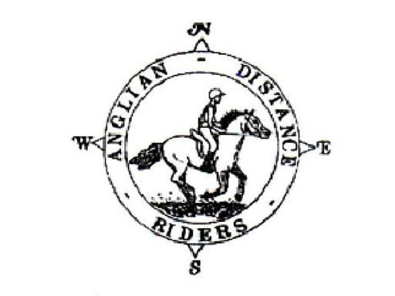

ANGLIAN DISTANCE RIDERS

**First & Fresh rescheduled date, now Sunday 23rd March 2025**

**Fire Route 210, Just off B1106, Kings Forest East**

**what3words app location: gave.quits.imprinted**

* **Riders to Start between 10am & noon**
* Horses must be 4 years old or over. An adult must accompany juniors aged between 8 and 13. A hard hat of PAS 015, VGI 01.040 (2014-12), SNELL E2001, SNELL E2016, AS/ZS 3838 (2006 onwards) or ASTM/SEI standard must be worn. Competitors may not ride in wellington boots and whips may not exceed 30” in length. Spurs and draw reins or similar are not permitted. Cyclists may not accompany riders.
* The organisers, stewards, helpers & landowners cannot accept liability for accidents, damage, injury or illness to competitors, spectators or any other person, property, servants, animals or horses/ponies in connection with or arising out of this ride. All competitors & persons attending the ride do so at their own risk. It shall be a condition of entry that each entrant shall indemnify the organisers against any legal action arising from any accidents or incidents whatsoever. Non-members must have their own third party liability insurance to the value of £10,000,000. By signing this form you accept these terms and conditions, recognizing that this is a Risk Sport and confirming that you have the competence to undertake the class you are entering.
* A copy of the rules will be on display at the ride or can be obtained from the website: http://angliandistanceriders.co.uk/index.php/ride-dates/ride-rules/
* All Junior Riders must have a signed Parental Consent form lodged with the Ride Organiser at the start of the ride. The Form is available from the Ride Dates page on the website.
* **We do require a copy of your horse’s vaccination card along with your entry for every horse participating in our rides. All vaccinations must be fully up to date, and if a booster or second vaccination is required, it must have been given a full 7 days before the ride. Entries will be refused if proof of vaccinations are not provided.**

|  |  |  |  |  |
| --- | --- | --- | --- | --- |
| **Entry Fees Per day** | **Adult Members** | **Junior Members** | **Adult Non-Members** | **Junior Non-Members** |
| **BEFORE closing date** | £20 | £10 | £25 | £20 |
| **AFTER closing date** | £25 | £15 | £30 | £25 |

**BACS Reference: FF2303 (BACS details - Account Name: Anglian Distance Riders**

**Sort Code: 20-16-12, Account Number: 43445240)**

(If you have already paid by BACS or cheque for the 5th January First & Fresh ride, please indicate on following page where highlighted, to help us cross-check / utilise that payment for you instead, thank you.)

**Please return completed entry form plus copy of vaccination certificate to:**

**Vikki Roberts, Hall Gardens, Gt Livermere, BSE, IP31 1JR**

**Tel: 07940288657**

**Email: sorcha1971@hotmail.co.uk**

**The closing date for this ride is: 18th March 2025**

**BACS PAYMENTS NEED TO BE DONE PRIOR TO RIDE DATE**

**THERE WILL BE NO ENTRIES ON THE DAY DUE TO PARKING RESTRICTIONS**



**First & Fresh, rescheduled date 23rd March 2025**

**Fire Route 210, Just off B1106, Kings Forest East**

NAME: ………………………………………………………………………………….

## TEL: ……………………………………………………………………………………...

D.O.B (if under 18)*:……………………………………………. **\*Please complete a Parental Consent form with Nominated**

**Adult to accompany all Junior Riders (8-13 years) from the ADR Website and submit with your entry**

Vehicle Registration Number:………………………………Next of Kin/Emergency Contact:…………………………………………………..

Horse Name:……………………………………………………………Horse Age:……………………………………. Gelding/Mare/Stallion

If you have any health issues (e.g., allergies, medication) that you feel the Ride Organiser should be aware of

please note here:…………………………………………………………………………………………………………………………………………………………………………

## Preferred start time: Early/Middle/Late **First riders to leave at 10AM, last rider to be on route by 12PM**

**The ride is 5/8/13 miles (Please circle the mileage you wish to do). A map and ride start times will be posted on the ADR Website.**

**Payment Options**

## I enclose a cheque for £………………. (Payable to Anglian Distance Riders) **Y/N**

* I will pay by BACS with reference **FF2303** (BACS details - Account Name: Anglian Distance Riders,

Sort Code: 20-16-12, Account Number: 43445240) **Y/N**

* I have already paid by BACS / cheque for the since cancelled 5th January 2025 First & Fresh ride; please use that payment for this 23rd March rescheduled ride. **Y/N**

**Ride Details Options**

## I will check the website for ride details **Y/N**

## I enclose a large SAE for ride details

## Please email details to:…………………………………………………………………………………………………………………………………………………………..

## In the event a ride is cancelled on the day of the ride, I confirm I can access the Website or Facebook page to check **Y/N**

## I give permission for any photos taken to be used on our social media and website **Y / N**

## 

## I confirm that I hold third party public liability insurance to £10m (Please tick)

Signed:……………………………………………………………………………ADR Bib No (Members Only) :…………………………………………………..

PLEASE INCLUDE A COPY OF YOUR HORSE’S VACCINATION CERTIFICATE WITH YOUR ENTRY. IF A COPY IS NOT INCLUDED YOU WILL NOT BE ENTERED.