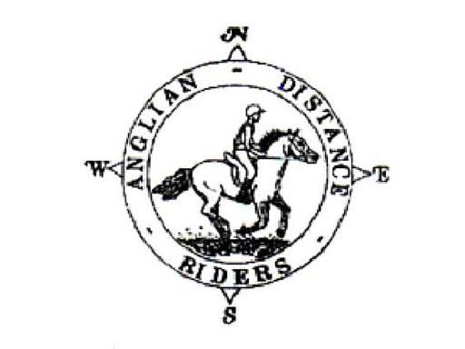

ANGLIAN DISTANCE RIDERS

**Herewald the Wake, Sunday 6th October**

**The Fox, Rampton, Cambridge CB24 8QF**

**what3words: final.hood.untruth**

* **Riders to Start between 10am and Noon**
* Horses must be 4 years old or over.
* An adult must accompany juniors aged between 8 and 13 and have a signed Parental Consent form lodged with the Ride Organiser at the start of the ride. The Form is available on the website.
* A hard hat of PAS 015, VGI 01.040 (2014-12), SNELL E2001, SNELL E2016, AS/ZS 3838 (2006 onwards) or ASTM/SEI standard must be worn.
* Competitors may not ride in wellington boots and whips may not exceed 30” in length. Spurs and draw reins or similar are not permitted.
* The Organisers, Stewards, helpers & landowners cannot accept liability for accidents, damage, injury or illness to competitors, spectators or any other person, property, servants, animals or horses/ponies in connection with or arising out of this ride. All competitors & person’s attending the ride do so at their own risk. It shall be a condition of entry that each entrant shall indemnify the Organisers against any legal action arising from any accidents or incidents whatsoever. Non-members must have their own third party liability insurance to the value of £10,000,000. By signing this form you accept these terms and conditions, recognizing that this is a Risk Sport and confirming that you have the competence to undertake the class you are entering.
* A copy of the rules will be on display at the ride or can be obtained from the website.
* **We require a copy of your horse’s vaccination card along with your entry for every horse participating in our rides. All vaccinations must be fully up to date, and if a booster or second vaccination is required, it must have been given a full 7 days before the ride.**

**If the vaccination copy is not received with your ride entry, entry will be refused and you will be unable to participate in our rides.**

|  |  |  |  |  |
| --- | --- | --- | --- | --- |
| **Entry Fees Per day** | **Adult Members** | **Junior Members** | **Adult Non-Members** | **Junior Non-Members** |
| **BEFORE closing date** | £20 | £10 | £25 | £20 |
| **AFTER closing date** | £25 | £15 | £30 | £25 |

**Please return completed entry form plus copy of vaccination certificate:**

**Sarah Cameron, The Fox, High Street, Rampton, Cambridge CB24 8QF**

**Tel: 07899 958925 R.O Email: pale.rider@live.co.uk**

**The closing date for this ride is: Monday 30th September 2024**

**ENTRIES ON THE DAY MUST BE PAID BY CASH OR CHEQUE ONLY,**

**BACS PAYMENTS NEED TO BE DONE PRIOR TO RIDE DATE**



**Herewald the Wake, Sunday 6th October 2024**

**The Fox, Rampton, Cambridge CB24 8QF**

NAME: ………………………………………………………………………………….

## TEL: ……………………………………………………………………………………...

D.O.B (if under 18)*:……………………………………………. **\*Please complete a Parental Consent form with Nominated**

**Adult to accompany all Junior Riders (8-13 years) from the ADR Website and submit with your entry**

Vehicle Registration Number:………………………………Next of Kin/Emergency Contact:…………………………………………………..

Horse Name:……………………………………………………………Horse Age:……………………………………. Gelding/Mare/Stallion

If you have any health issues (e.g., allergies, medication) that you feel the Ride Organiser should be aware of

please note here:…………………………………………………………………………………………………………………………………………………………………………

## Preferred start time: Early/Middle/Late **First riders to leave at 10AM, last rider to be on route by 12PM**

**The ride is 12 miles with a shorter option. A map and ride start times will be posted on the ADR Website.**

**Payment Options**

## I enclose a cheque for £………………. (Payable to Anglian Distance Riders) **Y/N**

* I will pay by BACS with reference **HW0610** (BACS details - Account Name: Anglian Distance Riders,

Sort Code: 20-16-12, Account Number: 43445240) **Y/N**

**Ride Details Options**

## I will check the website for ride details **Y/N**

## I enclose a large SAE for ride details

## Please email details to:…………………………………………………………………………………………………………………………………………………………..

## In the event a ride is cancelled on the day of the ride, I confirm I can access the Website or Facebook page to check **Y/N**

## I give permission for any photos taken to be used on our social media and website **Y / N**

## 

## I confirm that I hold third party public liability insurance to £10m **Y / N**

Signed:……………………………………………………………………………ADR Bib No (Members Only) :…………………………………………………..

PLEASE INCLUDE A COPY OF YOUR HORSE’S VACCINATION CERTIFICATE WITH YOUR ENTRY. IF A COPY IS NOT INCLUDED YOU WILL NOT BE ENTERED.