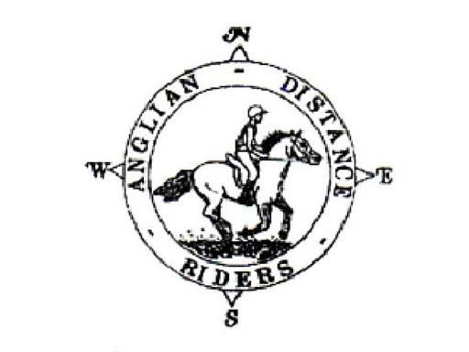

ANGLIAN DISTANCE RIDERS
Easter Bunny – Friday 29th March 2024
Hall Farm, Wordwell, IP28 6UW
Off the B1106
What3Words location: bonkers.handyman.posts
- Riders to Start between 10am & noon
- Horses must be 4 years old or over. An adult must accompany juniors aged between 8 and 13. A hard hat of PAS 015, VGI 01.040 (2014-12), SNELL E2001, SNELL E2016, AS/ZS 3838 (2006 onwards) or ASTM/SEI standard must be worn. Competitors may not ride in wellington boots and whips may not exceed 30” in length. Spurs and draw reins or similar are not permitted. Cyclists may not accompany riders.
- The organisers, stewards, helpers & landowners cannot accept liability for accidents, damage, injury or illness to competitors, spectators or any other person, property, servants, animals or horses/ponies in connection with or arising out of this ride. All competitors & person’s attending the ride do so at their own risk. It shall be a condition of entry that each entrant shall indemnify the organisers against any legal action arising from any accidents or incidents whatsoever. Non-members must have their own third party liability insurance to the value of £10,000,000. By signing this form you accept these terms and conditions, recognizing that this is a Risk Sport and confirming that you have the competence to undertake the class you are entering.
- A copy of the rules will be on display at the ride or can be obtained from the website: http://angliandistanceriders.co.uk/index.php/ride-dates/ride-rules/
- All Junior Riders must have a signed Parental Consent form lodged with the Ride Organiser at the start of the ride. The Form is available from the Ride Dates page on the website.
- We do require a copy of your horses vaccination card along with your entry for every horse participating in our rides. All vaccinations must be fully up to date, and if a booster or second vaccination is required, it must have been given a full 7 days before the ride. Entries will be refused if proof of vaccinations are not provided.

Entry Fees Per day | Adult Members | Junior Members | Adult Non-Members | Junior Non-Members
BEFORE closing date | £25 | £15 | £30 | £25
AFTER closing date | £30 | £20 | £35 | £30
BACS Reference: EB2903
(BACS details - Account Name: Anglian Distance Riders, Sort Code: 20-16-12, Account Number: 43445240)

Please return completed entry form plus copy of vaccination certificate to:
Di Luke, Rohan, Icklingham Road, West Stow, BSE, IP28 6EY
Tel: 07909 843958
Email: dianneluke@hotmail.com

The closing date for this ride is: 25th March ‘24

ENTRIES ON THE DAY MUST BE PAID BY CASH OR CHEQUE ONLY, BACS PAYMENTS NEED TO BE DONE PRIOR TO RIDE DATE

Easter Bunny 29th March ‘24
Wordwell, IP28 6UW

NAME: ……………………………………………………………………………………….

Contact Number:: ………………………………………………….

D.O.B (if under 18)*:……………………………..

Vehicle Registration Number:................................ Next of Kin/Emergency Contact: …………………………………………………….

Horse Name:..................................................... Horse Age............................. Gelding/Mare/Stallion

If you have any health issues (e.g., allergies, medication) that you feel the ride organiser should be aware of please note here:
……………………………………………………………………………………………………………………………………………………………………………………………………………………………………………………………………………………………………………………………………………………………………………………………………
Please detail below if you require a riding buddy/ assistance at the ride:
…………………………………………………………………………………………………………………………………………………………………………………………………………………………………………………………………………………………………………………………………………………………………………………………………….

Preferred start time: Early/Middle/Late * please circle

First riders to leave at 10am, last rider to be on route by noon.

The ride is distances of 6-16 miles. A map and ride start times with be posted on the ADR Website

I enclose a cheque for £………………. (Payable to Anglian Distance Riders) or

I will pay by BACS with reference: EB2903
(BACS details - Account Name: Anglian Distance Riders, Sort Code: 20-16-12, Account Number: 43445240)

I give permission for any photos taken to be used on our social media and website

In the event a ride is cancelled on the day of the ride, I confirm I can access the Website or Facebook to check

I confirm that I hold third party public liability insurance to £10m (please tick)

Signed …………………………….................………………….. ADR Bib No. ………………...

*Please complete a parental consent form and nominated adult to accompany any junior riders (8-13 years) from the ADR Website

*Please ensure ALL details on this form are filled in correctly*

